Student Counselling System
Aim: To create a cloud-based Student Counselling System using Zoho Creator to store student details and identify their academic and career interests
Procedure:
- Log in to Zoho Creator and create a new application.
- Create a form named Student Counselling Details.
- Add fields such as Student Name, Age, Address, Phone, Subjects Studied, Year of Passing, Percentage of Marks, and Domain Interest.
- Enter the student details and save the records.
- View the information to support counselling activities.
Implementation
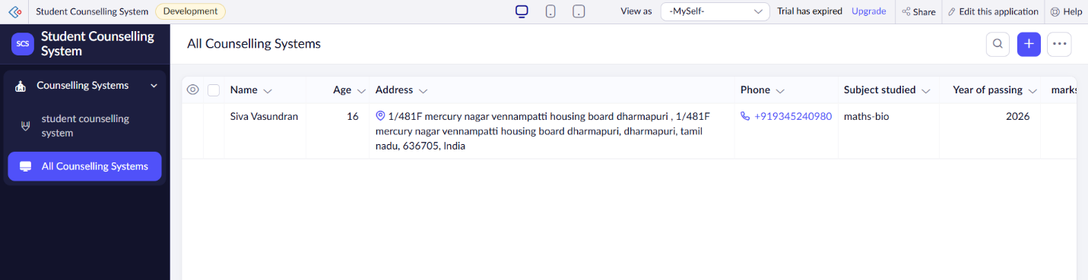
Result: Thus, a cloud-based Student Counselling System was created successfully to manage student information and career interests.

